1. • **What is OOP? List OOP concepts?**

OOP is a Object Oriented Programming language. It is based on objects. In this program divides into small parts called objects. It is used to implement real world entities like inheritance, polymorphism, abstraction in the program to make program efficient and easy to use. OOPs concepts are: -

1. **Class**

It is a collection of objects. Class is a collection of data member and member function with its behavior.

1. **Object**

Object is an instance of class, to create memory for class to access all the properties of class except private.

1. **Encapsulation**

Data hiding wrapping out of data into single unit. Ex. capsule, mobile.

1. **Polymorphism**

Ability to make one name having different form. Two types of polymorphism are: -

1. Method overloading (compile time)
2. Method Overriding (run time)
3. **Inheritance**

Properties of parent class derived into child class is called inheritance.

1. **Abstraction**

Essential part shows rest of part hidden.

OOPS concepts are as follows:

1. [Class](https://www.geeksforgeeks.org/classes-objects-java/)
2. [Object](https://www.geeksforgeeks.org/classes-objects-java/)
3. [Method](https://www.geeksforgeeks.org/methods-in-java/) and [method passing](https://www.geeksforgeeks.org/message-passing-in-java/)
4. Pillars of OOPs
   * [Abstraction](https://www.geeksforgeeks.org/abstraction-in-java-2/)
   * [Encapsulation](https://www.geeksforgeeks.org/encapsulation-in-java/)
   * [Inheritance](https://www.geeksforgeeks.org/inheritance-in-java/)
   * [Polymorphism](https://www.geeksforgeeks.org/polymorphism-in-java/)
     + Compile-time polymorphism
     + Runtime polymorphism

**3. What is the difference between OOP and POP?**

|  |  |
| --- | --- |
| P.O. P | O.O. P |
| 1. Procedure Oriented Programming language | 1. Object Oriented Programming language |
| 1. Focuses on Process not on data. | 1. Focuses on Data not process |
| 1. Top-Down Approach | 3. Bottom-UP Approach |

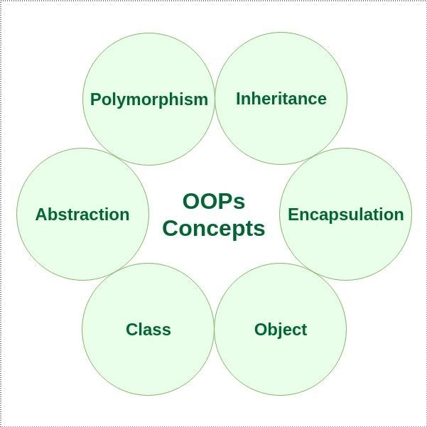

A [class i](https://www.geeksforgeeks.org/classes-objects-java/)s a user-defined blueprint or prototype from which objects are created. It represents the set of properties or methods that are common to all objects of one type. Using classes, you can create multiple objects with the same behavior instead of writing their code multiple times. This includes classes for objects occurring more than once in your code. In general, class declarations can include these components in order:

1. **Modifiers**: A class can be public or have default access (Refer to [this](https://www.geeksforgeeks.org/access-specifiers-for-classes-or-interfaces-in-java/) for details).
2. **Class name:** The class name should begin with the initial letter capitalized by convention.
3. **Superclass (if any):** The name of the class’s parent (superclass), if any, preceded by the keyword extends. A class can only extend (subclass) one parent.
4. **Interfaces (if any):** A comma-separated list of interfaces implemented by the class, if any, preceded by the keyword implements. A class can implement more than one interface.
5. **Body:** The class body is surrounded by braces, { }.

**An object** is a basic unit of Object-Oriented Programming that represents real-life entities. A typical Java program creates many objects, which as you know, interact by invoking methods. The objects are what perform your code, they are the part of your code visible to the viewer/user. An object mainly consists of:

1. **State**: It is represented by the attributes of an object. It also reflects the properties of an object.
2. **Behavior**: It is represented by the methods of an object. It also reflects the response of an object to other objects.
3. **Identity**: It is a unique name given to an object that enables it to interact with other objects.
4. [**Method**](https://www.geeksforgeeks.org/methods-in-java/)**:** A method is a collection of statements that perform some specific task and return the result to the caller. A method can perform some specific task without returning anything. Methods allow us to **reuse** the code without retyping it, which is why they are considered **time savers**. In Java, every method must be part of some class, which is different from languages like C, C++, and Python.
5. What is the difference between OOP and POP?

**Object-Oriented Programming (OOP)**

* + OOP treats data as a critical element in the program development and does not allow it to flow freely around the system.
  + In OOP, the major emphasis is on data rather than procedure (function).
  + It ties data more closely to the function that operate on it, and protects it from accidental modification from outside function.
  + OOP allows decomposition of a problem into a number of entities called objects and then builds data and function around these objects.
  + The data of an object can be accessed only by the function associated with that object. However, function of one object can access the function of other objects.
  + C++, Java, Dot Net, Python etc are the example of Object oriented programming (OOP) language.

# Some Characteristics of Object Oriented Programming:-

* + Emphasis is on data rather than procedure (function).
  + Programs are divided into objects.
  + Functions that operate on the data of an object are ties together in the data structure.
  + Data is hidden and cannot be accessed by external function.
  + Objects may communicate with each other through function.
  + New data and functions can be easily added whenever necessary.
  + Follows bottom up approach in program design.

# Features of OOP (Object Oriented Programming):-

1. Class
2. Object
3. Encapsulation
4. Data Abstraction
5. Inheritance
6. Polymorphism
7. Data binding
8. Message Passing

# Application of Object Oriented Programming:-

* + User interface design such as windows, menu
  + Real Time Systems such as Control system for cars, aircraft, space vehicles etc
  + Office automation system such as Document Management System

i.e. Word processing system, spread sheet software etc

* + AI and Expert System
  + Neural Networks and parallel programming System
  + Decision support system etc

# Advantages of OOP:-

1. **Improved software-development productivity:**

Object-oriented programming is modular, as it provides separation of duties in object-based program development. It is also extensible, as objects can be extended to include new attributes and behaviors. Objects can also be reused within an across applications. Because of these three factors – modularity, extensibility, and reusability – object-oriented programming provides improved software-development productivity over traditional procedure-based programming techniques.

1. **Improved software maintainability:**

Since the design is modular, part of the system can be updated in case of issues without a need to make large-scale changes.

1. **Faster development:**

Reuse enables faster development. Object-oriented programming languages come with rich libraries of objects, and code developed during projects is also reusable in future projects.

1. **Lower cost of development:**

The reuse of software also lowers the cost of development. Typically, more effort is put into the object-oriented analysis and design, which lowers the overall cost of development.